Watch this before → https://www.youtube.com/playlist?list=PLfq5z_tJn33A

Problem Statement
AI-Powered Restaurant Recommendation System (Zomato Use Case)
You are tasked with building an AI-powered restaurant recommendation service inspired by Zomato. The system should intelligently suggest restaurants based on user preferences by combining structured data with a Large Language Model (LLM).
Objective
Design and implement an application that:
- Takes user preferences (such as location, budget, cuisine, and ratings)
- Uses a real-world dataset of restaurants
- Leverages an LLM to generate personalized, human-like recommendations
- Displays clear and useful results to the user
System Workflow
- Data Ingestion
  - Load and preprocess the Zomato dataset from Hugging Face (https://huggingface.co/datasets/ManikaSaini/zomato-restaurant-recommendation )
  - Extract relevant fields such as restaurant name, location, cuisine, cost, rating, etc.
- User Input
  - Collect user preferences:
    - Location (e.g., Delhi, Bangalore)
    - Budget (low, medium, high)
    - Cuisine (e.g., Italian, Chinese)
    - Minimum rating
    - Any additional preferences (e.g., family-friendly, quick service)
- Integration Layer
  - Filter and prepare relevant restaurant data based on user input
  - Pass structured results into an LLM prompt
  - Design a prompt that helps the LLM reason and rank options
- Recommendation Engine
  - Use the LLM to:
    - Rank restaurants
    - Provide explanations (why each recommendation fits)
    - Optionally summarize choices
- Output Display
  - Present top recommendations in a user-friendly format:
    - Restaurant Name
    - Cuisine
    - Rating
    - Estimated Cost
    - AI-generated explanation

AI Tools
Any one of them
- https://cursor.com/download (Pro)
  - https://www.youtube.com/playlist?list=PLfq5z_tJn33A
- https://antigravity.google/product/antigravity-ide (JIO sim, 349 activate google pro + antigravity) (18 months)
- VS + Claude https://www.youtube.com/playlist?list=PL0yP9t93Zw_AyNcDz98-Tbi418nlGeoDz https://www.youtube.com/watch?v=r9asFt5iU9E&list=PL0yP9t93Zw_AyNcDz98-Tbi418nlGeoDz&index=2&t=2074s
https://www.youtube.com/playlist?list=PL0yP9t93Zw_AyNcDz98-Tbi418nlGeoDz
- VS + Codex
- VS + Copilot

STEPS
Understand Context Engineering (Advance Vibe Coding) → https://www.youtube.com/watch?v=weVIOp2s87w

Master-Project-Building-with-AI-Tools.pdf

More projects → https://www.youtube.com/playlist?list=PL0yP9t93Zw_DIMaYcCWsT3I53Y7HYo1cE

Context Setup
- Create docs folder
  - problemStatement.txt → basic problem statement
  - problemStatement.md → store context of the project you are building
  - architecture.md → detailed architecture of the project
  - implementation-plan.md → phase-wise implementation plan
  - edge-case.md → corner scenario
  - eval.md → evaluation scenarios for the project (evaluation each phase of our project)

Implementation
- Implement phase X using the implementation-plan

Diagram Flow

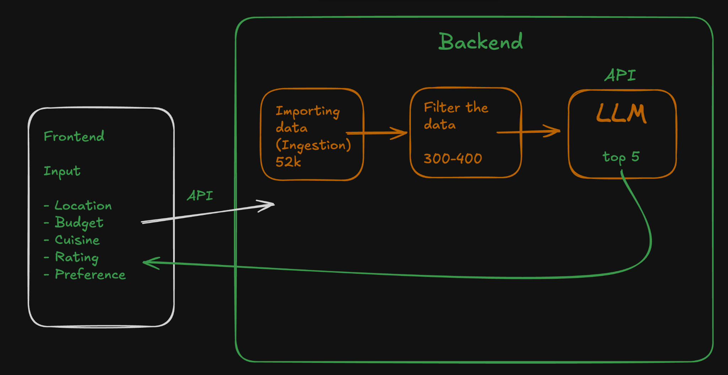

Prompt
- Generate a problemStatement.md which contains context of this project using @docs/problemStatement.txt
- Generate a detailed architecture.md for building this project using @problemStatement.md
- Generate phase-wise implementation-plan.md for this project using @architecture.md and @problemStatement.md
- Generate a edge-case.md which stores all the corner scenario and edgecases for this project using @implementation-plan.md @architecture.md
- Generate an eval.md for this project using @implementation-plan.md
- Implement phase0 as per the @implementation-plan.md
- Implement phase1 as per the @implementation-plan.md
- Implement phase2 as per the @implementation-plan.md
- Implement phase3 as per the @docs/implementation-plan.md

Integrating with LLM
- Groq → https://groq.com/ (Create API key)
- Google → https://aistudio.google.com/ (Create API key)

API key will be added in .env file
This .env you can ask cursor or antigravity to generate (copy the content from .env.example file)

- We can update the phase4 of @implementation-plan.md with Groq as LLM
- Implement phase4 as per the @implementation-plan.md
- I have added API key of groq, test whether connection to groq is working or not
make only one call
- Implement phase5 as per the @implementation-plan.md
- Run the project (both backend and frontend)

MANUAL VERIFICATION

- In location we have a dropdown of locations that are present
Cuisine we can make optional and not a compulsory field
- Stop the project

Model - openai/gpt-oss-120b
Request per minute - 30
request per day - 1K
Tokens per minute - 8K
Tokens per day - 200K

Currently these are the limits so can we make sure that we use bare minimum tokens in each call with reference to these limits

Optimizing the FRONTEND

Mistakes
High quality Model
Claude Opus 5, Sonnet 5, GPT Astra, GPT 5.6, Fable etc

Medium quality Model
Gemini Pro 3.x (High), Grok 4.7, GPT 5.5 etc

Low quality Model
Gemini Flash (CHAT), Locally hosted LLM

Cursor Pro
- Auto

Shortcuts
Ctrl + Shift + V → Preview markdown file
Cmd + Shift + V → Preview markdown file
Extensions → Parquet, SQL etc

